**COURSEWORK**

**Portfolio 2**

**SANDBOX APPLICATION**

NAME: ARCHANA BINDHU

STUDENT ID: A000254426

1. **NETWORK DIAGRAM**

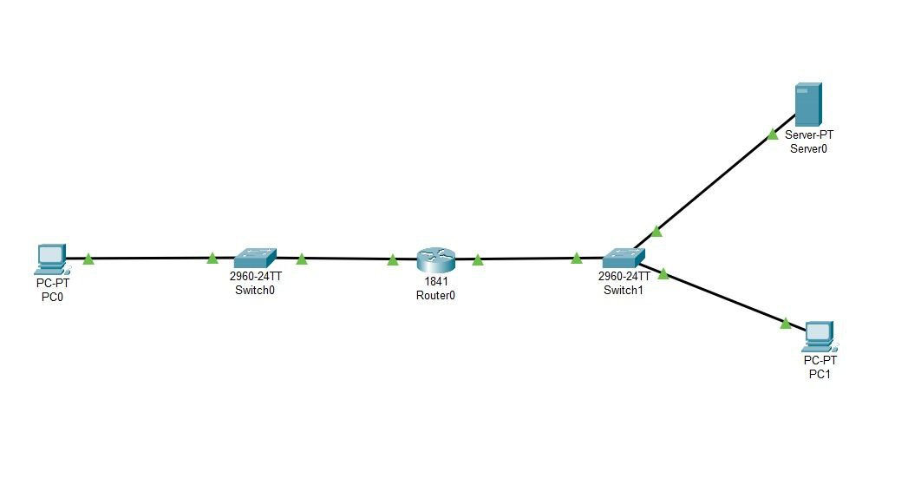

**STEPS:**

**Gateway Router:**

* Router1> enable
* Router1# configure terminal
* Router1(config)# interface fastethernet 0/0
* Router1(config-if)# ip address 192.168.9.1 255.255.255.0
* Router1(config-if)# no shutdown
* Router1(config-if)# exit
* Router1(config)# interface fastethernet 0/1
* Router1(config-if)#ip address 192.168.109.1 255.255.255.0
* Router1(config-if)#no shutdown
* Router(config-if)#ex

**Desktop (PC):**

* Click the PC and open it then go to the desktop >IP Configuration>change to static> Set IP address.

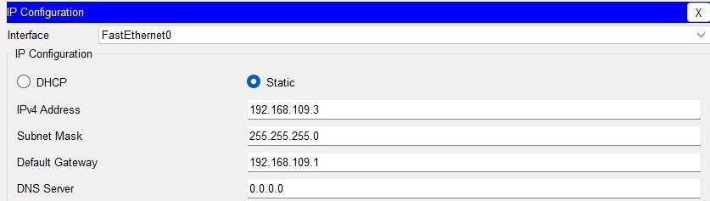

* Set all PC for this.
* And ping 192.168.9.1

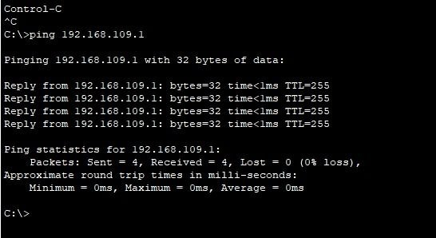

**Screenshot for pinging PC to Gateway**

**Application Server:**

* Click the Application Server and open then go to the desktop > IP Configuration>change to static>Set IP address.

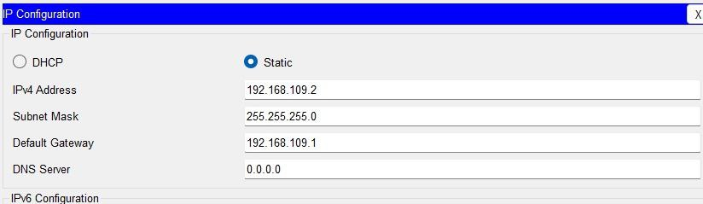

* Click the Application Server and open then go to the service >Click HTTP>Turn on HTTP and>HTTPS > and HTML page in Application Server.
* Click the Application Server and open it then goes to the Desktop>Web Browser>Type the IP address 192.168.109.2

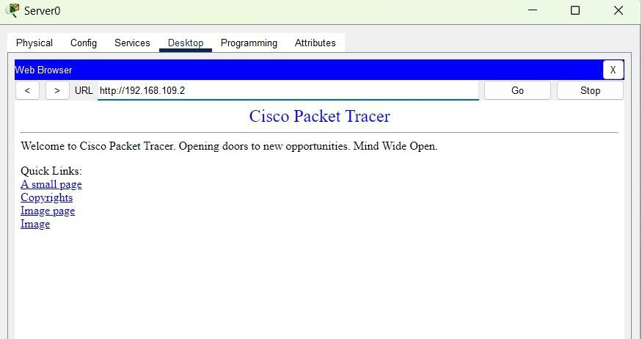

**Screenshot for web server showing a web site in web browser**

**2. IP ADDRESS TABLE**

|  |  |  |  |
| --- | --- | --- | --- |
| **DEVICE** | **ROLE** | **IP ADDRESS** | **SUBNET MASK** |
| Desktop VM  (Ubuntu Desktop) | Management | 192.168.9.2 | 255.255.255.0 |
| Gateway Router VM  (enpOs3)  (Ubuntu Server) | Internet Access | 10.0.2.15 | 255.255.255.0 |
| Gateway Router VM  (enpOs8) | Subnet 01- Internal Network | 192.168.9.1 | 255.255.255.0 |
| Gateway Router VM  (enpOs9)  (Ubuntu Server) | Subnet 02- Internal Network | 192.168.109.1 | 255.255.255.0 |
| Application Server VM  (Bitnami) | Server | 192.168.109.2 | 255.255.255.0 |

**3. GIT PAGES LAB REPORT**

Github Project link:- <https://archanasandbox.github.io/archana-sandbox/>

Github File link:- <https://github.com/archanasandbox/archana-sandbox.git>

**CONFIGRATION STEPS:**

* You need to create three VM Machine’s for this project.
* Download the Virtual Box (VM) and install.
* Download the three OS :
* Ubuntu Desktop (.iso format) or our Desktop OS like ( kali, Linux, windows etc..)
* Ubuntu Server OS (.iso format)
* Application Server in Bitnami Wordpress (.ova format)
* Add the three OS in Virtual Box.

**UBUNTU SERVER OS CONFIGURATION STEPS:**

**Step 1:**

**Create a new Virtual Machine (VM) for Ubuntu Server**

* Open VirtualBox
* Click on new to create a new virtual machine.
* Name the VM ( eg; Ubuntu Server)
* Select the type as Linux and the version as Ubuntu ( 64-bit)
* Allocate memory ( RAM) for the VM (eg: 2048 or higher based on our systems capacity).
* Choose to create a virtual hard disk now and set a sufficient disk size ( eg: 10 GB)
* Click Create.

**Step 2:**

**Configure the Network Interfaces**

You need two network interfaces on the Ubuntu Server VM to act as a router between the two subnets:

* Go to **Settings** then select **Network.**
* **On Adapter 1:**
* Set to Internal Network (name it to intnet). This will be for subnet.
* Click the Advanced tab and set the adapter type to PCnet-FAST III or another supported type. Note: Within the ubuntu server terminal, this card will typically have a network adapter name of enp0s8.
* **On Adapter 2:**
* Enable this adapter and set it to another Internal Network (name it differently, e.g., intnet1). This will be for Subnet 2.
* Within the ubuntu server terminal, this card will typically have a network adapter name of enp0s9.
* **On Adapter 3:**
* Set to NAT. Note: Within the ubuntu server terminal, this card will typically have a network adapter name of enp0s3.
* Its IP address will be assigned via DHCP.
* It will be used to provide access to the internet via the host computer.

**Step 3:**

**Install Ubuntu Server**

* Start the VM and select the Ubuntu Server ISO as the boot disk.
* Go through the installation process.
* Set your time zone, keyboard layout etc.
* Create a user account and set a strong password.
* Then select the option to install Open SSH server
* Complete the installation and then reboot the VM.

**Step 4:**

**Configure Static IPs on the Network Interfaces**

* After installation we need to assign static IP addresses to both network interfaces (each in different subnets).
* Log in to the Ubuntu Server VM
* Edit the network configuration file:
* - sudo nano /etc/netplan/00-installer-config.yaml
* Type the code.

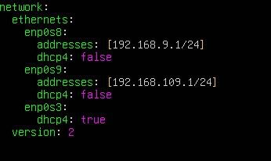

* Save it (CTRL +X) > type YES > and then ENTER
* Apply the network change
* sudo netplan apply
* ip a

**Step 5:**

**Enable IP Forwarding**

To allow routing between the two subnets you need to enable IP forwarding.

* Open the sysctl configuration file:

- sudo nano /etc/sysctl.conf

* Uncomment the line or add it if it is not present

- net.ipv4_forward=1

* Apply the changes:

- sudo sysctl -p

**Step 6:**

**Set Up IPTables for Routing**

You may also want to configure iptables to ensure packets are forwarded between the subnets.

* Configure iptables to allow forwarding:

❖ sudo iptables -A FORWARD -i enp0s3 -o enp0s8 -j ACCEPT

❖ sudo iptables -A FORWARD -i enp0s8 -o enp0s3 -j ACCEPT

* To make the changes permanent, you can save the iptables rules:

❖ sudo apt install iptables-persistent

❖ sudo netfilter-persistent save

❖ sudo netfilter-persistent reload

**Ubuntu OS Configuration Steps:**

**Steps:**

**Installing Ubuntu Desktop in VM**

To create a virtual machine and install a GUI-based OS from an ISO file

* Launch VirtualBox
* Click “New” to create a new machine
* Fill in the details as requested so that the new machine is:

❖ Named “Ubuntu Desktop”

❖ The ISO named “ubuntu-24.04.1-desktop-amd64.iso” is selected

❖ The checkbox for “Skip Unattended Installation” is checked

* Click “Next”. Now ensure the machine has:

❖ 2048mb of Base Memory

❖ Two processors

* Click “Next”. Create a Virtual Hard Disk for the machine. This will need to be a minimum of 25GB.
* Click “Next”. Verify your settings are as above and click “Finish”.
* Click “Start” to boot your virtual machine
* Select “Try or Install Ubuntu”
* Click “Install Ubuntu”
* You need to create an Ubuntu account and click a Restart Now.

**Step 2:**

**Configure the Network Interfaces**

You need one network interfaces on the Ubuntu Desktop VM.

* Go to Settings of your new VM.
* Select Network.
* **Adapter 1**: Set to Internal Network (name it differently, e.g., intnet).
* Open Ubuntu desktop in VM and login.
* Go to the settings > Network> enp0s3 setting> IPV4 > IPV4 Method change to (Manual)> Add address =192.168.22.2, Add netmask =255.255.255.0 or 24, Add gateway =192.168.22.1
* Apply
* Disconnect the Network and connect.

**Bitnami Web Application Configuration Step:**

To create a Bitnami virtual machine using VirtualBox

**Step 1:**

**Install Bitnami Application in VM.**

* Click “File” then “Import appliance”.
* Navigate to the file named “bitnami-wordpress-6.3.1-r0-debian-11-amd64.ova”.
* Click “Open”.
* Click “Next”.
* Click “Finish”.
* Click “Start” to launch the machine.
* The first-time log in details is displayed on-screen.
* You will be required to reset the password on your first log in.
* Close the Bitnami.

**Step 2:**

**Configure the Network Interfaces**

* Go to Settings of your new VM.
* Select Network.
* **Adapter 1**: Set to Internal Network (name it differently, e.g., intnet1).
* Open Bitnami Application in VM and login.
* Type the code

❖ sudo nano /etc/network/interfaces

❖ auto enp0s3

iface enp0s3 inet static

address 192.168.122.2

netmask 255.255.255.0

gateway 192.168.122.1

❖ Save it (CTRL + X) type (yes) and enter.

❖ sudo ifdown enp0s3 && sudo ifup enp0s3

❖ sudo systemctl restart networking

* ip a

**4.FUNCTIONAL TEST RESULTS**

Evidence that all the VM’s can communicate as per the design ( eg ; ping results, screenshots of application access).

**Screenshots for Functional Test Results :**

**Ubuntu Server OS:**

* Network IP configuration for Ubuntu Server:

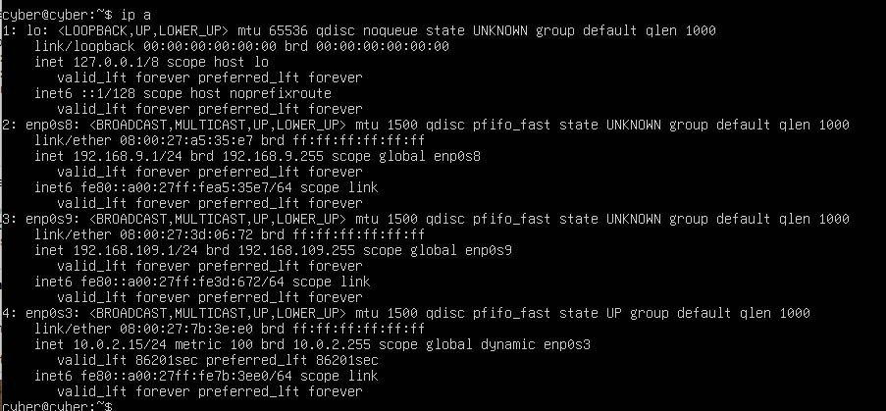

* Ping Ubuntu Server to Ubuntu Desktop Using IP address 192.168.9.2

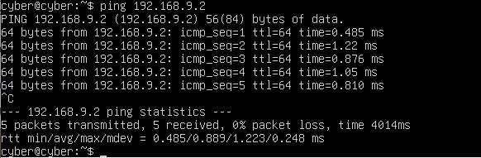

* Ping Ubuntu Server to Ubuntu Desktop Using IP address 192.168.109.2

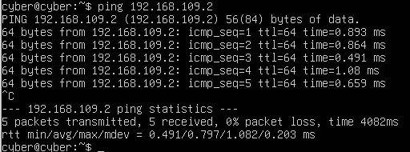

**Ubuntu Desktop OS:**

* Network IP Configuration for Ubuntu Desktop

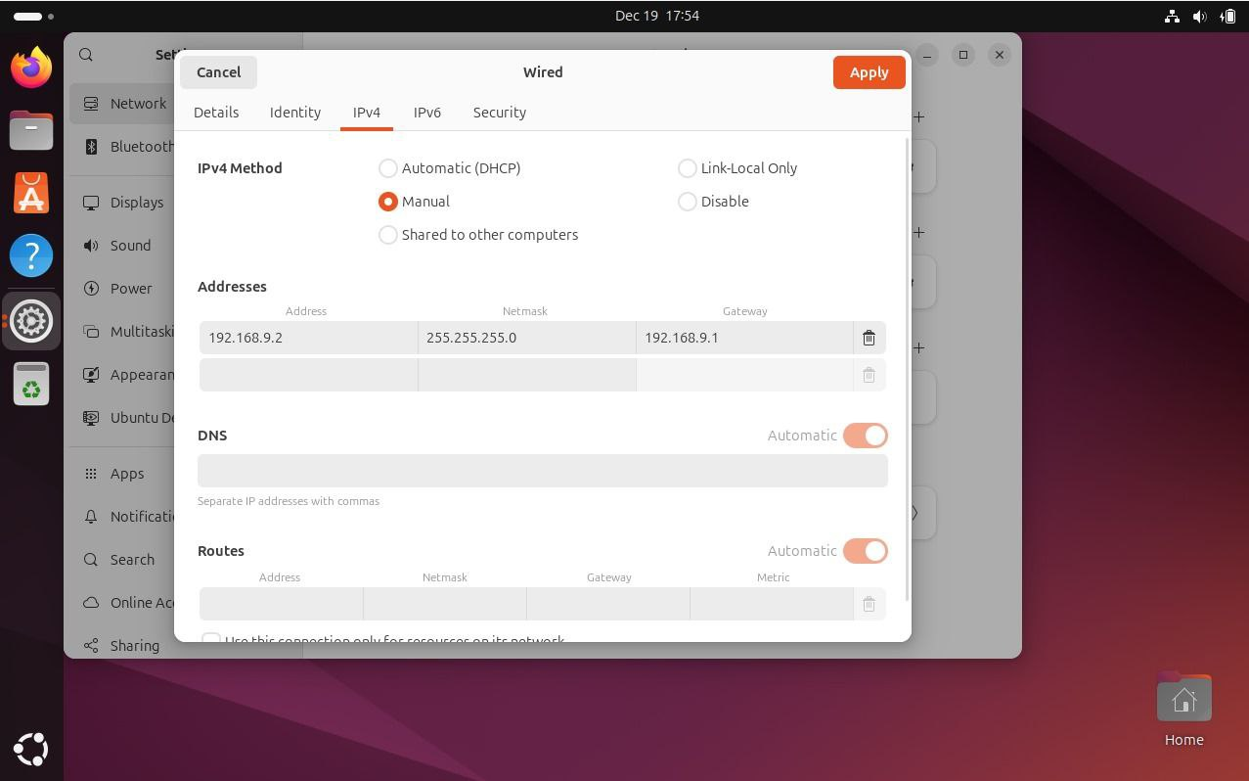

* Ping Ubuntu Desktop to Ubuntu Server Using IP address 192.168.9.1.

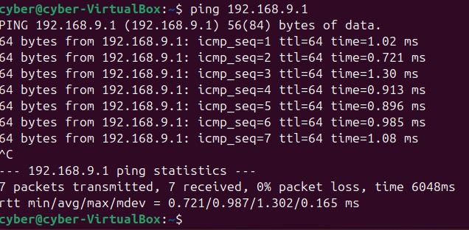

**BITNAMI APPLICATION SERVER:**

* Network IP configuration for Bitnami Application Server

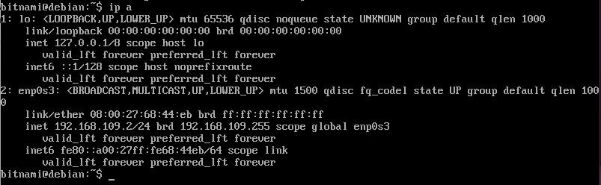

* Ping Bitnami Application Server to Ubuntu Server Using IP address 192.168.109.1

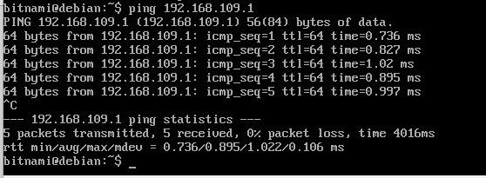

**Screen Recording:**

[**https://youtu.be/Bce0Qz-iDj4**](https://youtu.be/Bce0Qz-iDj4)

[](https://youtu.be/Bce0Qz-iDj4)